Mise-en-scène Applied to Level Design: Adapting a Holistic Approach to Level Design
Heather Logas
Telltale Games
1201 Andersen Dr. Suite A
San Rafael, CA, 94901
415-258-1638
hlogas@jetgirl.net
Daniel Muller
Georgia Institute of Technology
332281 Georgia Tech Station
Atlanta, GA 30332-1435
770-719-0050
danny.muller@gmail.com

ABSTRACT
As game developers strive to introduce a stronger sense of emotion into their games, new opportunities are presented to the level designer to imbue their virtual spaces with deeper symbols and meaning. Since the very beginning of film, the exploration of the concept of mise-en-scéne (literally “put in the scene”) has allowed filmmakers to convey sub-text to the viewer by the careful consideration of how each frame looks. A definition of mise-en-scéne is given; its connections to level design are explained and then illustrated by an analysis of Stanley Kubrick’s The Shining and Konami’s Silent Hill 4: The Room.

Keywords
mise-en-scène, level design
The art of level design is used very effectively in some games to evoke a certain mood in the player. In pursuing a more emotional experience in games, level design can be leveraged to reinforce not only emotion, but hint at psychological factors affecting the computer-controlled characters and reveal the narrative. Filmmakers have been using mise-en-scène to accomplish this since the advent of film.
In film, mise-en-scéne is a holistic approach to constructing a frame. Everything that is visible in a given scene is selected by the film director to communicate information to the viewer, both on a conscious and sub-conscious level. Survival horror games particularly tend to use the elements of the level to achieve a sense of immersive horror in the player. A holistic approach to level design creates a greater sense of immersion in the player and can communicate to the player on an emotional level. Mise-en-scène takes this several steps further than even the most carefully planned level design. Studying the techniques of mise-en-scéne and taking a holistic approach to level design may help game and level designers tap even deeper into the player and allow for communication at a sub-conscious level.

mise-en-scène and level design
Mise-en-scène is defined by film theorist Robert Kolker as: “the use of space within the frame: the placement of actors and props, the relationship of the camera to the space in front of it, camera movement, the use of color or black and white, lighting, the size of the screen frame itself”. [3] It is a French term that literally translates, “put in the scene”. It includes cinematography, lighting, blocking of actors, art direction, set dressing, costumes, props, and use of color. The mise-en-scéne informs everything about the film and gives filmmakers a rich palette to induce emotions in their audiences. By arranging elements on screen in a certain way, film directors can create mood, atmosphere, tension and conflict in the filmic space that is not achievable through any other means.

In their article, “The Art of Contested Spaces,” Henry Jenkins and his collaborator Kurt Squire make the case that game designers are able to create more meaningful and evocative game spaces by referencing existing artistic traditions. [2] They cite the legacy of romanticism and surrealism as having an impact on game designers Peter Molyneux (Black and White), Brenda Laurel (Secret Forrest games), and American McGee (Alice). “In Molyneux’s Black and White, player’s choices have clearly defined consequences which are made manifest on the physical environment, much as the Romantic artists used landscapes to express allegorical or moral visions.” They refer to mise-en-scène in melodrama, and how some game designers are incorporating mise-en-scène to create mood and atmosphere. Jenkins and Squire specifically mention Yu Suzuki’s Shenmue: “Grey skies and snowy streets contribute to the game’s sad, contemplative mood, expressing Ryo’s (the game’s adolescent protagonist) experience of mourning and loss.”

The level designer is the member of the game development team that designs and builds the spaces that the player will explore through their in-game persona. The level designer works with the art director to design the look and feel of the spaces in the game. The designer builds the space, places within it props and set dressing, textures the objects so that they appear the proper colors and styles, and lights the area. With the exception of cinematography (handled differently in different studios, but rarely by the level designer), blocking of characters (which in game design is controlled by the placement of cameras) and costuming (the responsibility of the person designing characters), the level designer is responsible for the elements which in film constitute the mise-en-scéne.
To understand better how mise-en-scéne would be a useful tool for level designers, it is necessary to deconstruct the mise-en-scéne of a classic film. For purposes of this paper, we have chosen Stanley Kubrick’s, The Shining. It is a highly organized and structured work that engages the viewer through an elaborate mise-en-scéne. The Shining is also very game-like in the fact that its action is almost completely limited to the Overlook Hotel and its topiary maze. Since level designers must contain their gameplay to a certain amount of levels, The Shining is a great example of how limited resources can be crafted in such a way as to have multiple layers of meaning and interest.

Analysis of The Shining
At its most basic, The Shining is a simple haunted house movie. In the hands of a lesser director, it would have been a typical B-movie like The Amityville Horror with some good scares but nothing more. In the hands of Kubrick and his faithful cast and crew, the film becomes a statement about the breakdown of Western Culture, the dissolution of the nuclear family, spousal and child abuse, perverted patriarchal structures, and the power of women.
Since mise-en-scéne is a combination of film techniques – cinematography, lighting, blocking of actors, art direction, set dressing, costumes, props, and use of color – it is important to look at these various aspects of the film and see how they work together to create a greater whole.
From the opening credits, the human characters are dwarfed in relation to other objects. Jack drives his yellow VW beetle along a winding mountain road to get to the Overlook Hotel for his job interview as the winter caretaker of the hotel. His little car looks like a bug traversing the vast mountain landscape. The camera glides above him, watching his slow progress up the mountain, until it takes off with an intention of its own. Already Kubrick has established the presence of the supernatural force that will battle his characters. A force that is huge and overpowering, in contrast to the tiny human being dwarfed by the natural landscape.
The set design of the Overlook Hotel is also huge and overpowering. In the scene where Jack and his family arrive to begin their winter stay, the camera glides along in parallel with them as they are dwarfed by the enormous room. Even the outside landscape disappears through the windows to be replaced by brilliant, featureless light. The building controls what the characters see or do not see. The association of the Overlook with a vast labyrinthine maze begins immediately as they are given a tour of the intricate corridors of the hotel. Wendy’s character even comments on this as she fears she needs to leave a trail of breadcrumbs to find her way back. The set designer spent the time and effort necessary to dress up the Overlook to be one of the main characters of the story.
The art direction in The Shining is meticulous in its attention to detail. Scattered throughout the hotel are framed photos of famous people who have stayed at the Overlook over the years. The photos occur in many scenes as background decoration, but at the end of the film we track into one of the black and white photos dated from 1921 to see Jack front and center. The photograph itself is a trap, with Jack locked inside the glass like an insect trapped in amber; he has always been at the Overlook and always will be, as one of the ghosts has pointed out to him.
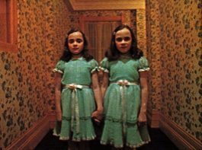
Figure 1.1: The twin girls blocking Danny’s path. (The Shining, 1980)
A very elaborate color scheme adds complexity to the hotel interiors. Gold, pink, red, white, orange and blue are all colors that dominate the backgrounds of the hotel, and contain associated meanings. Even the carpets have elaborate patterns and colors that are reminiscent of an inescapable labyrinth. When Jack is talking with Delbert Grady, the ghost of the caretaker who murdered his own family, the conversation takes place in a bathroom that is painted red and white. The red overwhelms the scene, giving us the feel that Jack has already descended into hell. The scene where Grady’s twin daughters confront Jack’s young son Danny takes place in a hallway decorated with brightly colored floral wallpaper (Figure 1.1). The flowers become an ironic counterpoint to the grisly image of the girls chopped up with an axe and the carpet and walls stained with their blood.
Lighting places an important part in setting the atmosphere in The Shining. In the beginning, Jack is lit from above with a diffuse light that softens his features. The light is warm and inviting, with amber and peach tones that evoke a sense of peace and tranquility. As Jack descends into madness, the lighting of his character changes to match his altered state. The scenes in the Gold Room bar show Jack illuminated from below, as the bar counter itself becomes the source of light; his facial features are distorted by the strange angle of the light. Ultimately the color shifts completely to a chilly blue as Jack hunts Danny inside the snow-filled maze. Jack no longer has the color of a human being, but of a specter (Figure 1.2).
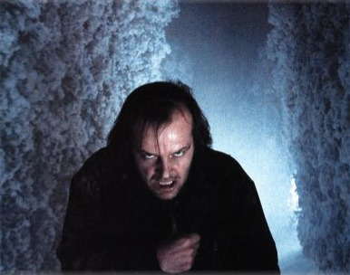
Figure 1.2: Jack hunting Danny in the topiary maze.
Atmospheric effects are used throughout the film to evoke mood and atmosphere. When Jack’s family first arrives at the hotel, the mountain behind the Overlook is covered by a strangely-shaped lenticular cloud; the cloud imparts a sense of otherworldliness that adds a layer of foreboding to the shot. In the scene where Danny is trying to escape from Jack inside the maze, swirling clouds of snow and mist obscure the action and add to the suspense. When Wendy and Danny escape in the snowmobile, their departure is covered by veil of swirling snow that we sense has been generated by the spirits of the Overlook. Jack’s path has been blocked, and the next shot shows Jack frozen to death in the pale light of morning. The Overlook’s exterior appearance changes from day to day, with snow piling higher and higher on its sides and distorting its shape to reflect its morphing character. Another remarkable scene occurs in the Gold Ballroom when Jack finds himself at a party full of guests dressed in costumes from the 1920’s; the room is filled with a smoky haze that filters everything with a dull light. Again, the filmmakers give us visual clues that the spirit world has intersected with the world of the living.
Props are used to create mood and add tension to scenes. Danny’s tricycle allows him to glide through the various hallways of the Overlook, and gives the camera a logical reason to fly down the corridors behind him. With every turn into a new corridor, we expect to meet some kind of terror. The sudden jolt we get when his way is blocked by the twin girls is confounded by our expectation of movement through the space. This encounter would have been much less dramatic if Danny had simply walked or ran down the corridor.
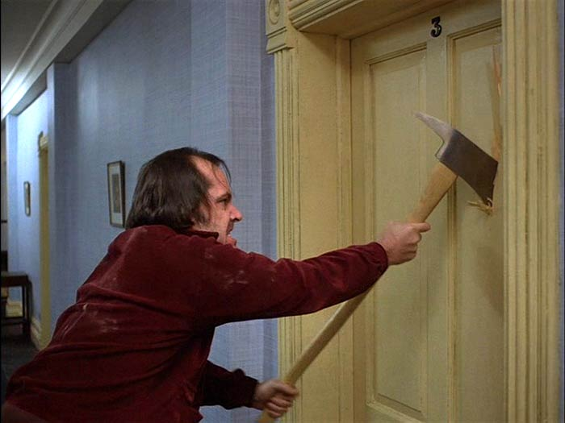
Figure 1.3: Jack wielding his fireman’s axe.
The choice of weapons throughout the film mocks the suburban lifestyle. Initially Wendy defends herself from Jack using a baseball bat, an object designed for recreation and health. Jack chooses a fireman’s axe (Figure 1.3) as his weapon of choice, while Wendy protects herself with a long kitchen knife. All of these props are forced into uses that contradict their original designs – the fireman’s axe is designed to break down doors to save people, not kill them, while the kitchen knife is designed to cut up food for human consumption, and not to skewer them. By reassigning these objects to new tasks, Kubrick plays with our notion of what is safe and what is not, and taunts us with our prior associations of these objects to domestic tranquility.

Analysis of SILENT HILL 4: The Room
Among games, the survival horror genre is perhaps most advanced in the use of mise-en-scéne to create a mood in the player. As in The Shining, this mood is one of slowly evolving dread and terror. Silent Hill 4: The Room is the most recent release in the Silent Hill series of games. Like its predecessors, close attention is given to creating an atmosphere of tension and horror. In their post-mortem on the game in Game Developer Magazine, developers Akihiro Imamura and Akira Yamoaka discuss the nature of horror in the series.
While the Silent Hill series lies firmly in the horror/action adventure genre, the root of the terror is not a fear of being attacked and killed by horrific creatures. Rather, it is a psychological terror of being slowly stalked and cornered by unknown beings. It’s not really about the shock value, but much more of a deeper sense of foreboding; you know something is coming, but you don’t know when and you can’t stop it. [1]
The level design in Silent Hill 4 makes splendid use of the concepts of mise-en-scéne to help capture this foreboding.
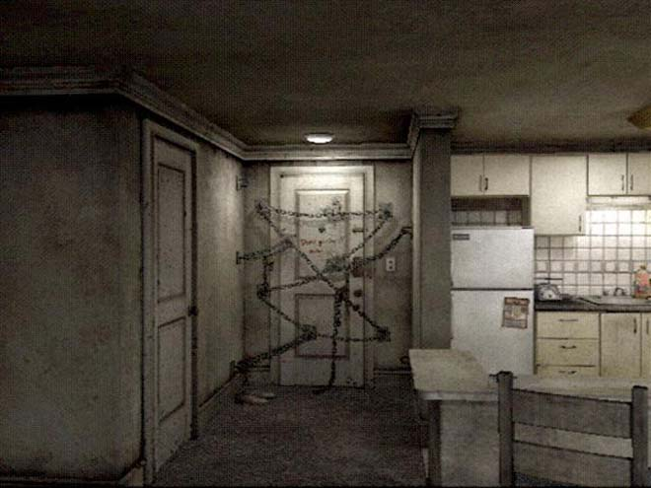
Figure 1.4: The chained up door allows no exit. (Silent Hill 4, Konami, 2004)
As indicated by the title, The Room takes place in the apartment of the main character, Henry Townsend. Just as the Overlook Hotel becomes an important character in The Shining, Room 302 of South Ashfield Heights becomes a character that the player will come to know all too well. Room 302 at first glance is a simple apartment with a bedroom, a bathroom, a living room/kitchen area, and a laundry room. At the onset of the game, there are two obvious signs of something being very wrong. The front door of the apartment has been chained up from the inside by an impossible criss-crossing network of heavy chains. (Figure 1.4) In the bathroom (the location of prime vulnerability in a house) a gaping hole has appeared in the wall. Should the player take the time to examine the area around the hole, the level designer has left clues that this hole had been punched inward, into the bathroom.
Henry is trapped in his apartment with no contact to the outside world. He leaves through the hole in the bathroom and enters one disturbing place after another, with his only avenue of escape being a hole in that world which connects to his bathroom. Even though there is a tense menace in not being able to escape the apartment, at the same time it is a sanctuary. It is here that the player can save the game and can also store and retrieve items that they might need for the next encounter. As the game progresses, however, the apartment itself slowly changes to reveal more and more menacing details. The simple arrangement of furniture allows the player to quickly become accustomed and familiar with how things are laid out, and take immediate notice if something is amiss.
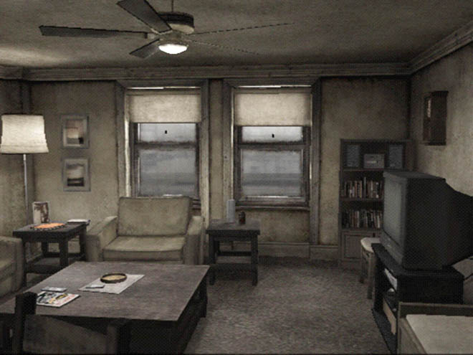
Figure 1.5: Room 203: sparse and somber.
Even in its original “normal” state, the apartment does not convey a sense of placidity. (Figure 1.5) The apartment scenes take place in the first person, which allows the player to examine things closely and conveys a feeling of being in the space. The ceilings feel low and cramped, creating a feeling of claustrophobia in the player. The palette of everything in the apartment is primarily grays and yellows, with some browns. The walls are not white, but an off-white that is tempered with dingy gray and just a hint of yellow in some areas. The lighting is diffused, and gives everything in the bedroom and living room a flat, gray appearance. The furniture in the apartment is very sparse and Spartan. The doors are pock-marked. The decorations on the walls are peaceful landscapes that contrast sharply with the horror that Henry is about to go through. Even so, a sense of foreboding is caused in the player by Henry’s explanation that these photos were taken at Silent Hill – the location of previous horrible events in previous games.
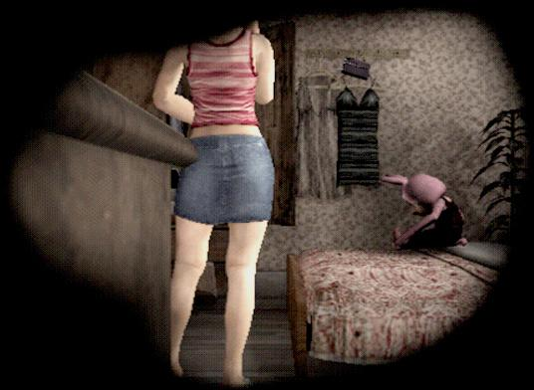
Figure 1.6: The room next door as seen through a hole in the wall.
Henry is able to look out the windows of his apartment, and even through a small hole in the wall to his next-door neighbor’s room. Looking out the windows the player sees a bustling city. Dozens of people go about their gray but sunlit day, free to wander where they choose and oblivious to the man who can’t leave his room and join them. Looking through the hole in the wall, Henry can see a little bit of the girl next-door’s apartment. (Figure 1.6) While Henry’s room is grayish and empty, her room has pink flowered wallpaper, a pink stuffed bunny on the bed and a wardrobe with clothes hanging on the open door. Her room exudes a tone of life, while Henry’s exudes a tone of staleness and entropy.
In designing the apartment, the level designer imparts things about the story to the player on several different levels. On a location level, this room has obviously been here a very long time and has never been looked after particularly well. On a personal level, Henry seems to be a neat, quiet and sentimental individual (in addition to the Silent Hill photos, his apartment also contains photos of himself as a child and in high school). Finally, on an emotional level, the room expresses a mood of uneasiness and slow decay – even before the actual decay of the room into a nightmare space begins.

CONCLUSION
Although the texts we have examined in this paper are both firmly rooted in the horror genre, mise-en-scéne in used in all genres of film to imbue scenes with the full range of human emotion, from sorrow to exuberance. In the world of games, however, the techniques of mise-en-scéne seem to have matured most in the survival-horror genre. Although level designers use similar techniques in all types of games, seldom are they adapted to the level that tugs on the player’s psyche as in well crafted films. In the future, level designers have the opportunity to become a very important part of creating more emotional experiences in games. Examining the ways mise-en-scéne is used in film will help these designers adapt a holistic approach to their own discipline and create deeper resonance with the player for whom the game is ultimately created.

REFERENCES
1. Imamura, A. & Yamoaka, A. “What’s Inside the Room? The Horror of Silent Hill 4 Investigated”, Game Developer Magazine, (March 2005) pp34-40.
2. Jenkins, H., & Squire, K. (2002). The Art of Contested Spaces. In L. King & C. Bain (Eds.), Game On. London: Barbican.

3. Kolker, R. Film, Form, and Culture. Boston: McGraw Hill, 1999.

