n0NsentiEnce
Character Specifications
Matt Musante – Lead Artist

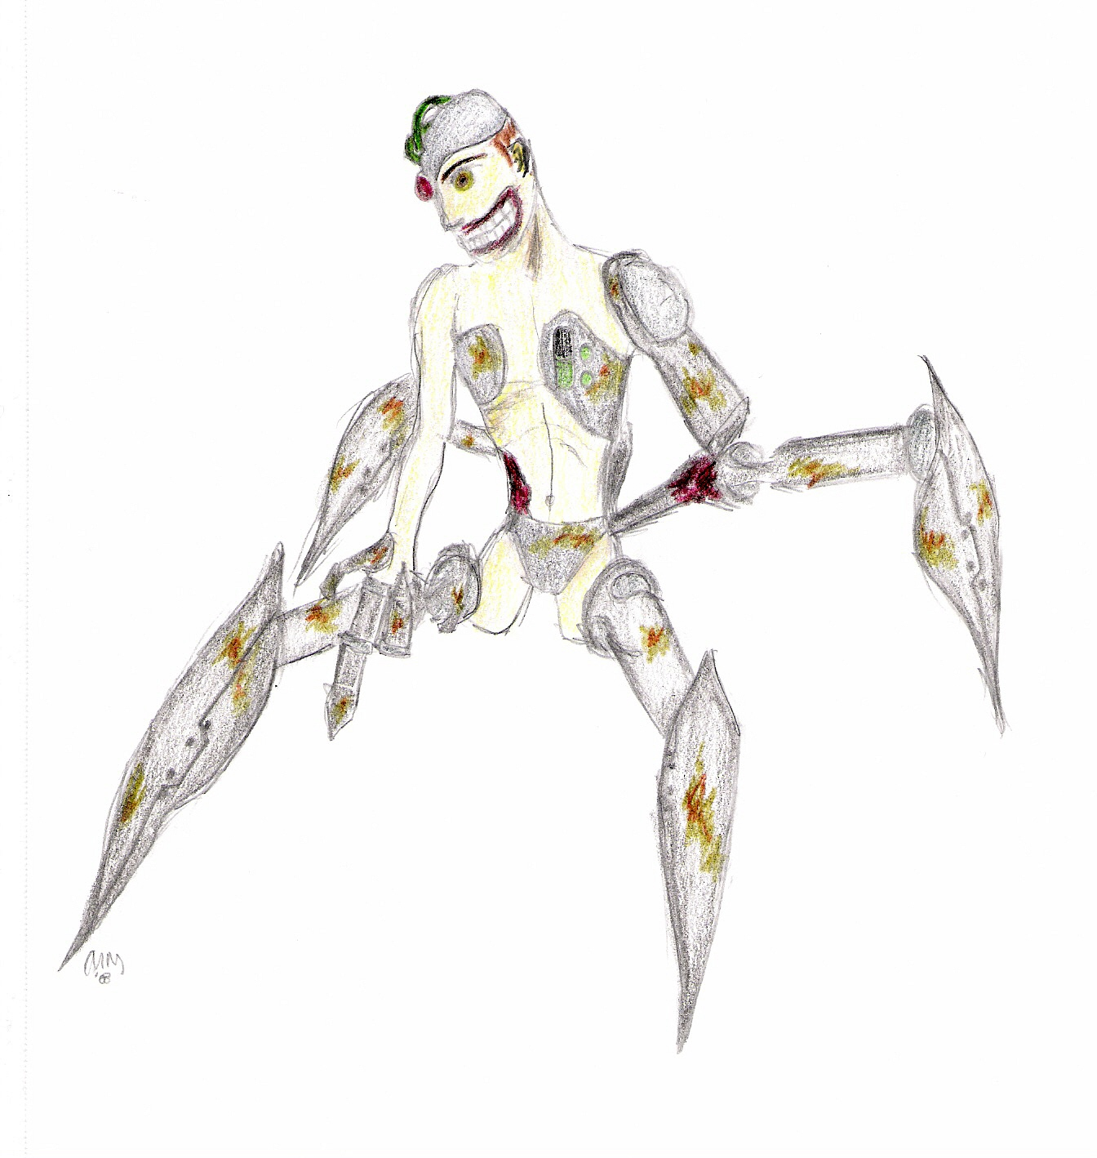
Merlin
Age: 8 (original), 8 + 22 (full)
Height: 4’10” (full)
Weight: 165lbs. (full; heavy cybernetic parts)
Eyes: Red (right) Brown (left)
Hair: None; Bald Metal
Facial Features: Various cybernetic implants cover a large portion of head, left jaw is exposed due to tissue decay
Color Scheme: dark grey (metallic parts), light grey (joints), brown/orange (rusted segments), dark red (muscle tissue), dark yellow-beige (jaundiced skin) neon green (battery interface over heart), dark green (brain tubes)
Characteristics: Stares vacantly and NEVER BLINKS, mouth does not move when speaking, head tends to roll lazily to the side when not moving or when speaking, gestures inadequately with left arm stump, over-exaggerates gestures when speaking to robots, very terse gestures when interacting with Dr. Edmunds or another cyborg, gradually uses more open gestures as he comes to know and trust Delta.

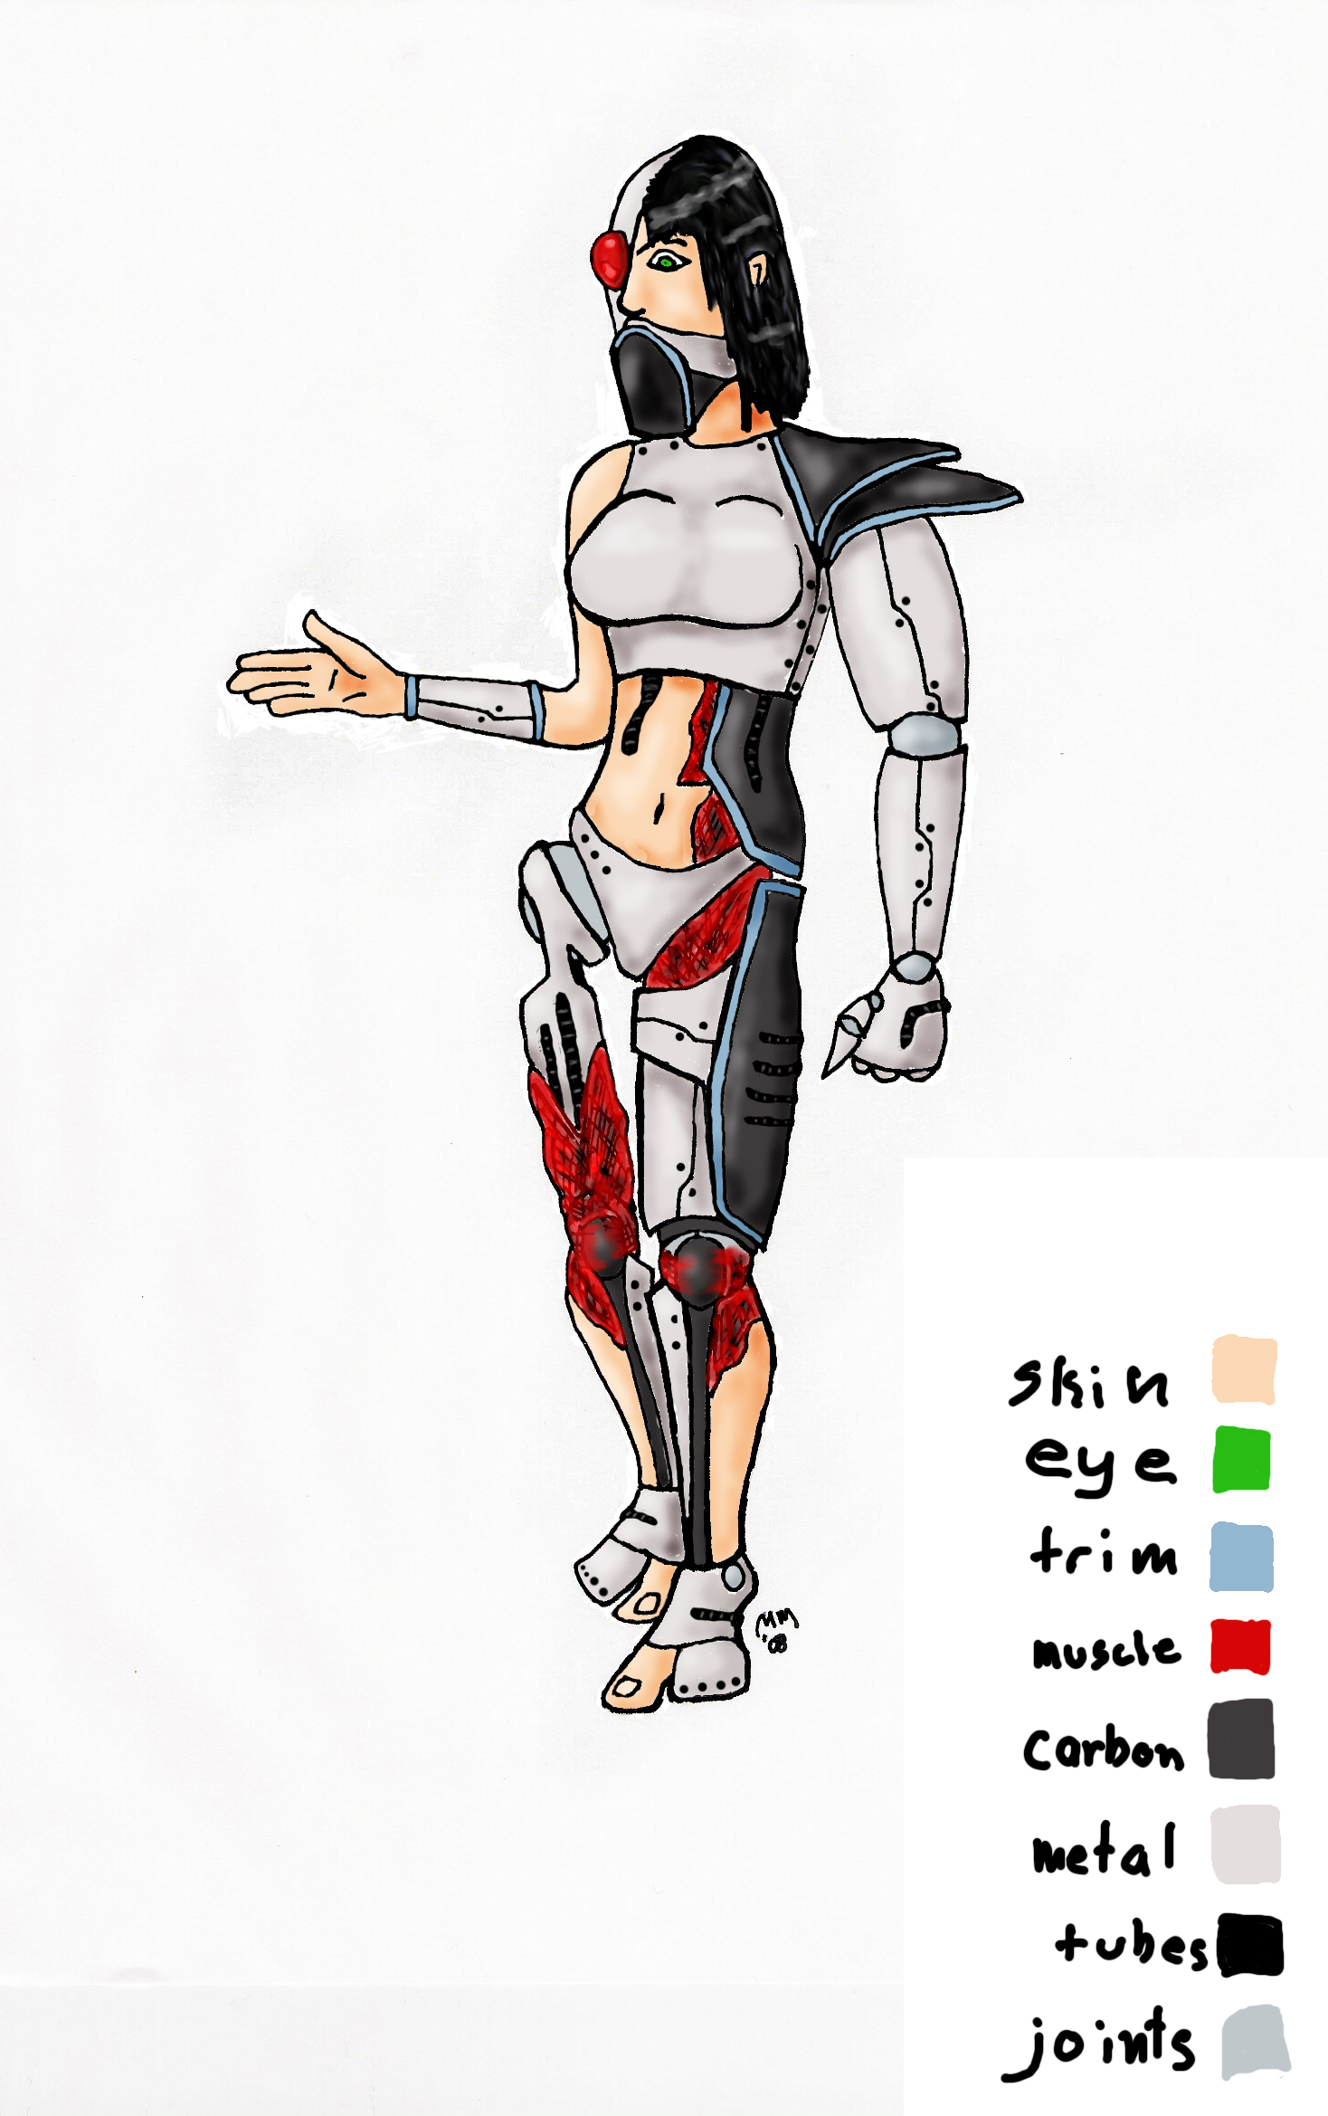
Delta
Age: 22 (original), ?? (full)
Height: 5’8”
Weight: 156lbs. (light cybernetic parts)
Eyes: Red (right) Green (left)
Hair: Black and clumpy
Facial Features: 50/50 cybernetic split, left half untouched human, right half completely cybernetic, ventilator/speakerbox installed over mouth due to severe jaw/mouth trauma
Color Scheme: light grey/white (titanium/plastic alloy), dark grey/black (carbon fiber plating), white (joints), black (tubing), yellow (plating trim), dark red (muscle tissue), dark peach (skin)
Characteristics: Confused and shaken, inquisitive and cautious, absolutely does not like what’s going on around her because she cannot understand or fully comprehend it, very guarded emotionally and when speaking, very minimalist gestures, comes to see herself as Merlin’s guardian (older sister type figure).

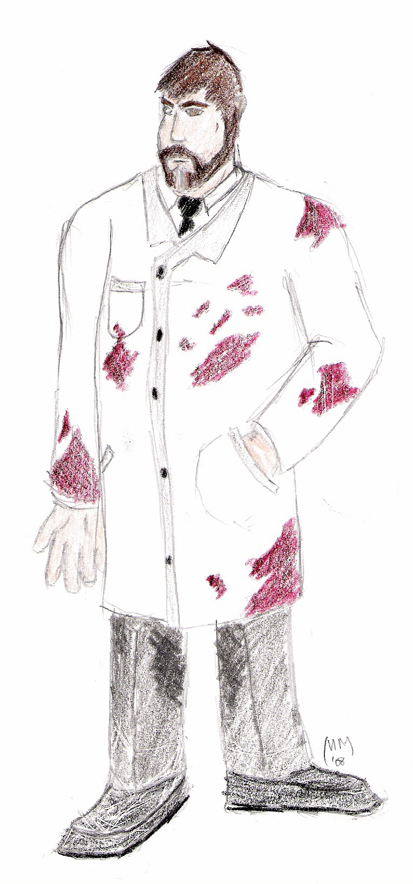
Dr. Edmunds
Age: 53
Height: 6’1”
Weight: 263lbs.
Eyes: Brown
Hair: Dark Brown
Facial Features: round, softer features, carefully groomed beard (also dark brown, with stripe of white down chin)
Color Scheme: white (lab coat, shirt), dark grey (slacks), black (shoes, tie), red (blood splatters), peach (skin)
Characteristics: Power tripping god complex, thinks burying corpses are a waste of possible scientific research, watches Delta’s struggles with mild bemusement, regards Merlin as his son, but refuses to acknowledge this publicly, and interacts with him as though he is just another robot, began his research after his only child and son died at the age of 8, producing Merlin as his first creation, is the sole owner of his clandestine underground research laboratory where he performs Frankensteinian experiments attempting to produce artificial life out of death and inanimate objects, studies the effects of mental disorders on artificial intelligence as a hobby.

His research is largely unpublicized due to the EXTREMELY controversial nature of his experiments, however his successes have been noted and cataloged, and passed on to larger clandestine operations interested (think Black Mesa or Apperture).

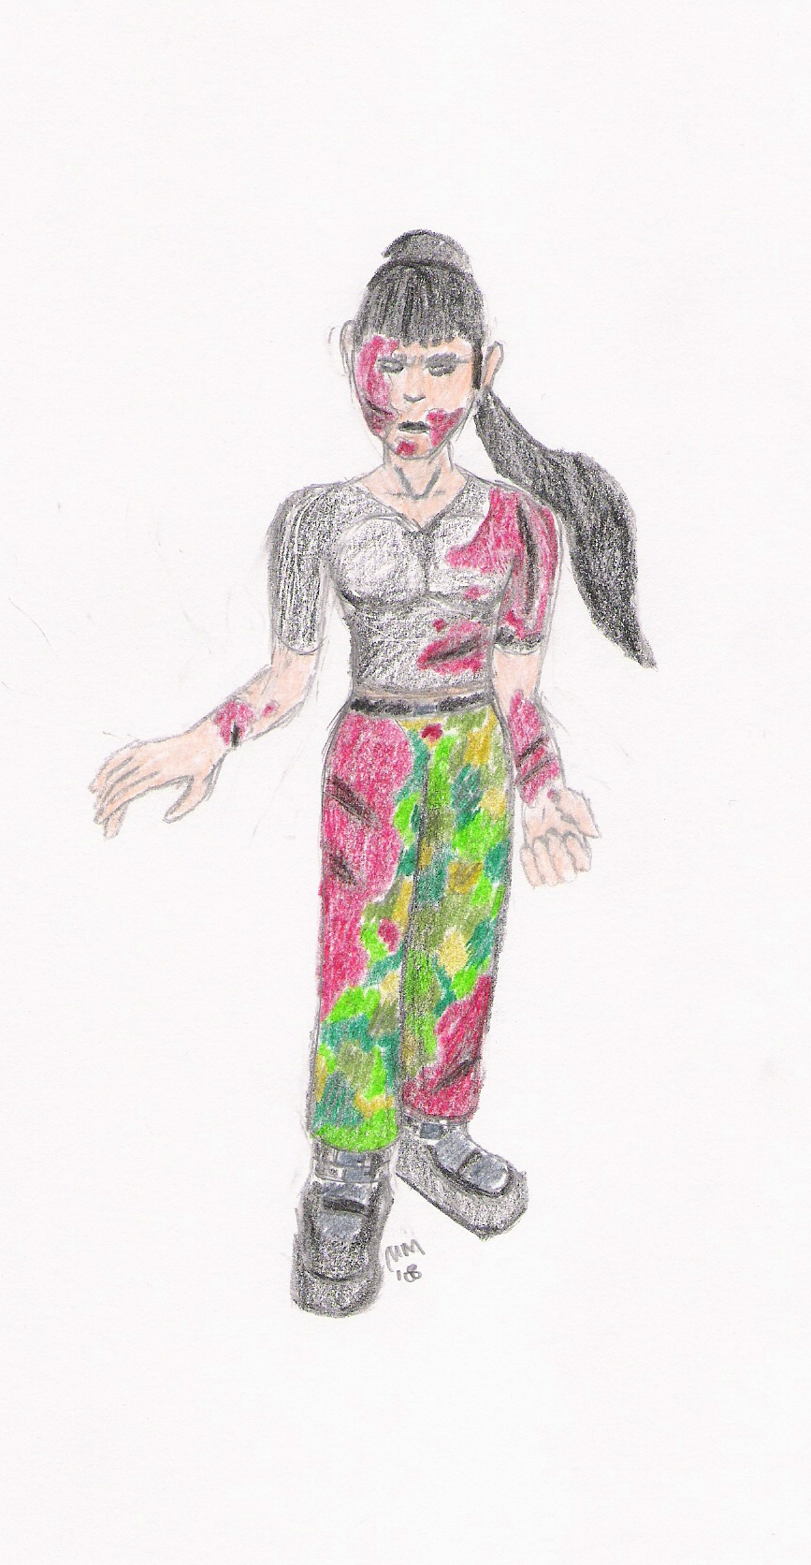
Justine
Age: 22
Height: 5’8”
Weight: 138lbs.
Eyes: Green or Glowing Red
Hair: Black
Facial Features: black lipstick, eyes are often covered in shadows, black eyeliner
Color Scheme: dark yellow/beige (skin), black (shirt, boots), dark green (pants), red (blood splatters, boot trim)
Characteristics: A malevolent spirit seeking to obtain her body again in hopes of laying herself to rest, is bound to the remnants of her body and awakens when Delta is turned on, infects Delta, attempting to tear her apart from the inside out, as Delta regains control of herself, Justine gets increasingly more powerful and can manipulate the material world, and eventually pulls Delta into the spiritual realm, extremely emotional and unstable, is often either sobbing and depressed or screaming and enraged.

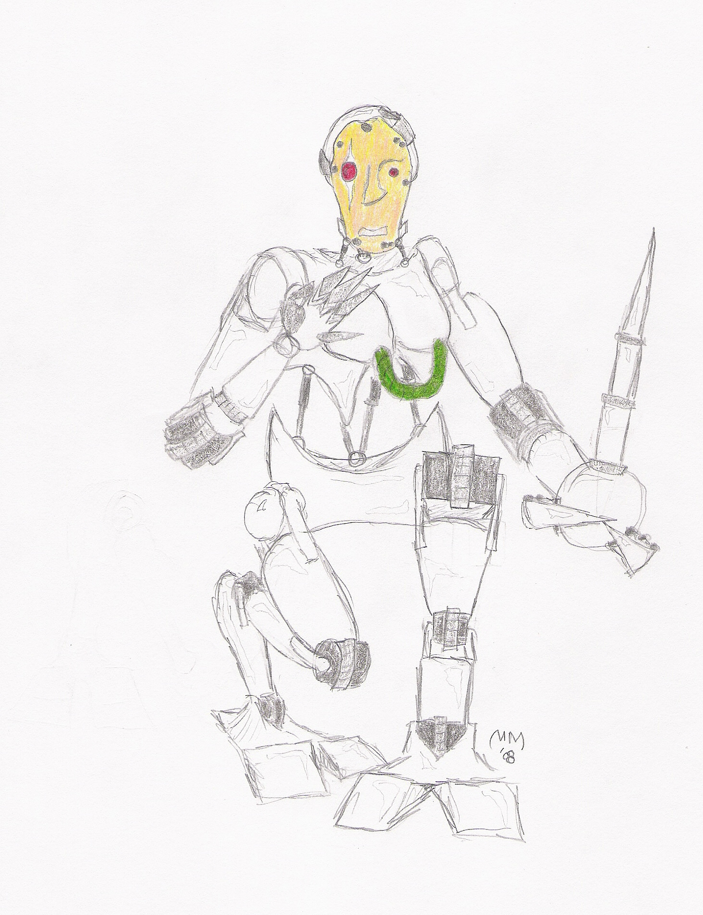
J.E.S.S.
Age: Unknown
Height: 10’
Weight: 450lbs. (relatively lightweight pieces, hollow in some areas)
Eyes: Red
Hair: None
Facial Features: Rivetted on flesh face; duplicate of Justine’s
Color Scheme: light grey/white (metal/plastic alloy), grey (joints, rivets, pneumatic tubes), white (ball joints), dark yellow/beige (jaundiced face), dark green (tubing)
Characteristics: Massive hulking android capable of tearing Delta apart quite easily, uses her massive physical presence to bully Delta, displays a very nurturing and motherly attitude towards Delta, and continually rambles on about how she’s “only looking out for your well being” while simultaneously pinning Delta to the ground, cannot be defeated with physical assault as she will simply pin Delta and then either throw her away, contain her, or dispose of her.

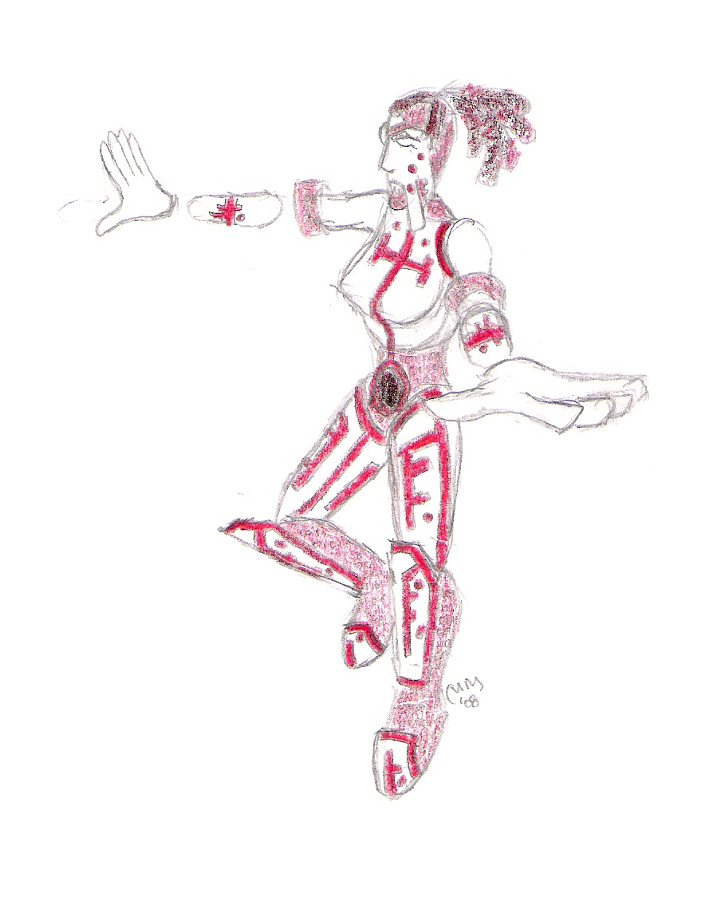
jU5t33Nz
Age: Unknown
Height: 5’
Weight: 80lbs. (largely insubstantial)
Eyes: Red (left eye usually closed, but is also Red)
Hair: black wires, cords, and tubes with red coiling accents
Facial Features: binary skin obfuscated by a white mask with various holes and engravings, all facial features are part of the mask, left eye usually closed, right eye is a mimic of thematic cyborg eye
Color Scheme: dark red (binary skin), bright red (trim), white (mask, armor)
Characteristics: Speaks like a text to voice program with extreme tone shifts for no apparent reason, attempts to control Delta’s mind, and failing that, to destroy it, constantly ridicules and lies to Delta, cannot be defeated by physical assault as she is often surrounded by various protective layers, and barring that, is largely immaterial.

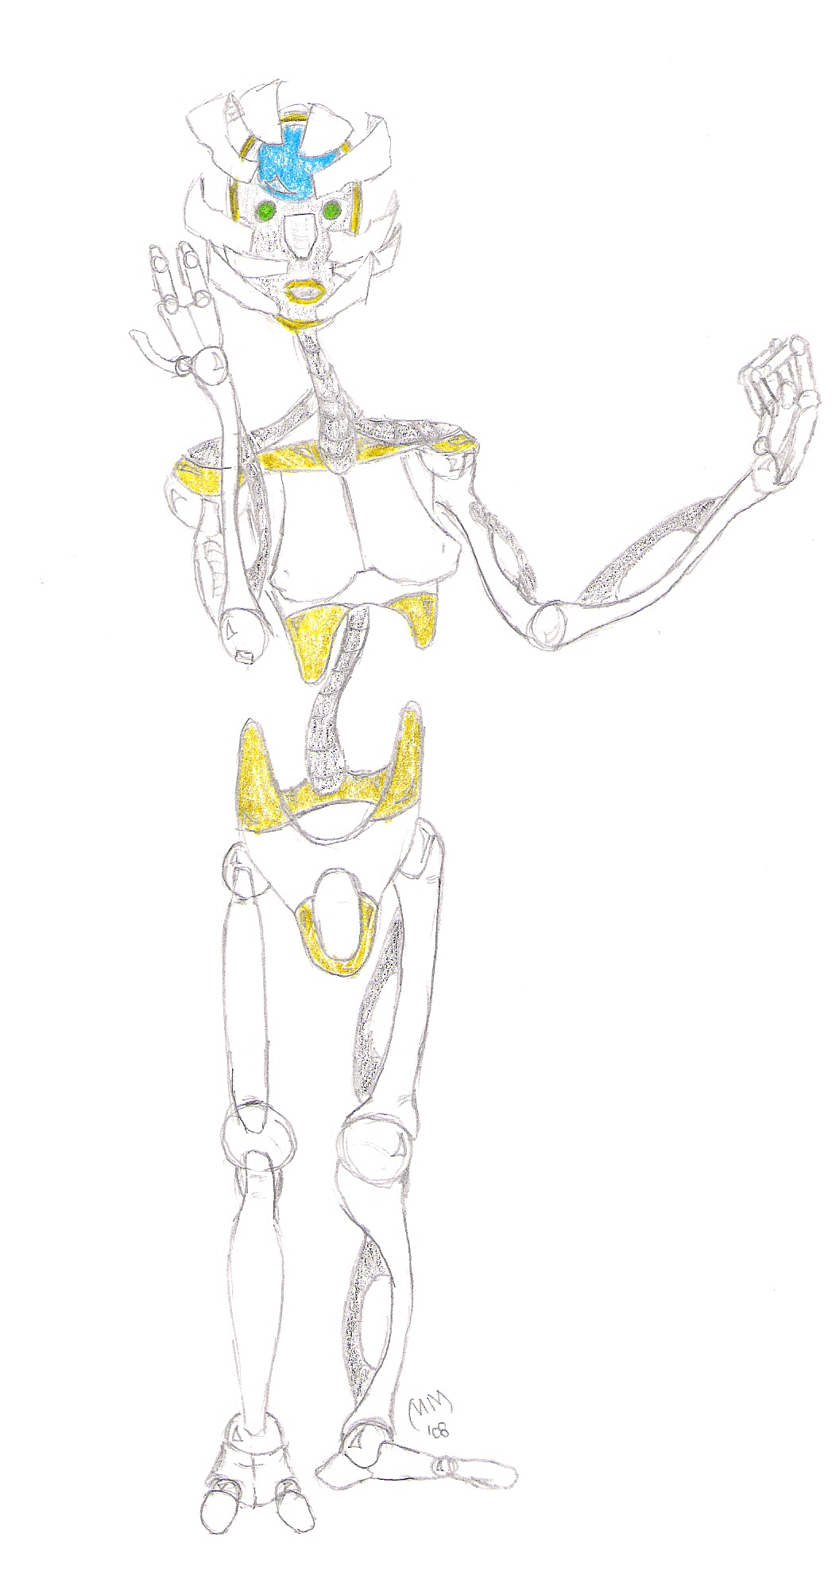
Delta_Android
Age: Unknown
Height: 5’ 8”
Weight: 122lbs. (light plastic shell)
Eyes: Green
Hair: None
Facial Features: smooth plastic alloy face is comprised of various plates that constantly shift outward, exposing the hollow head cavity and spherical android brain
Color Scheme: white (body, ball joints), black (body), gold (details, lips), blue (brain sphere)
Characteristics: Same as Delta, when experiencing extreme emotional reactions, face “shatters” to reveal components underneath, electronic quality to voice

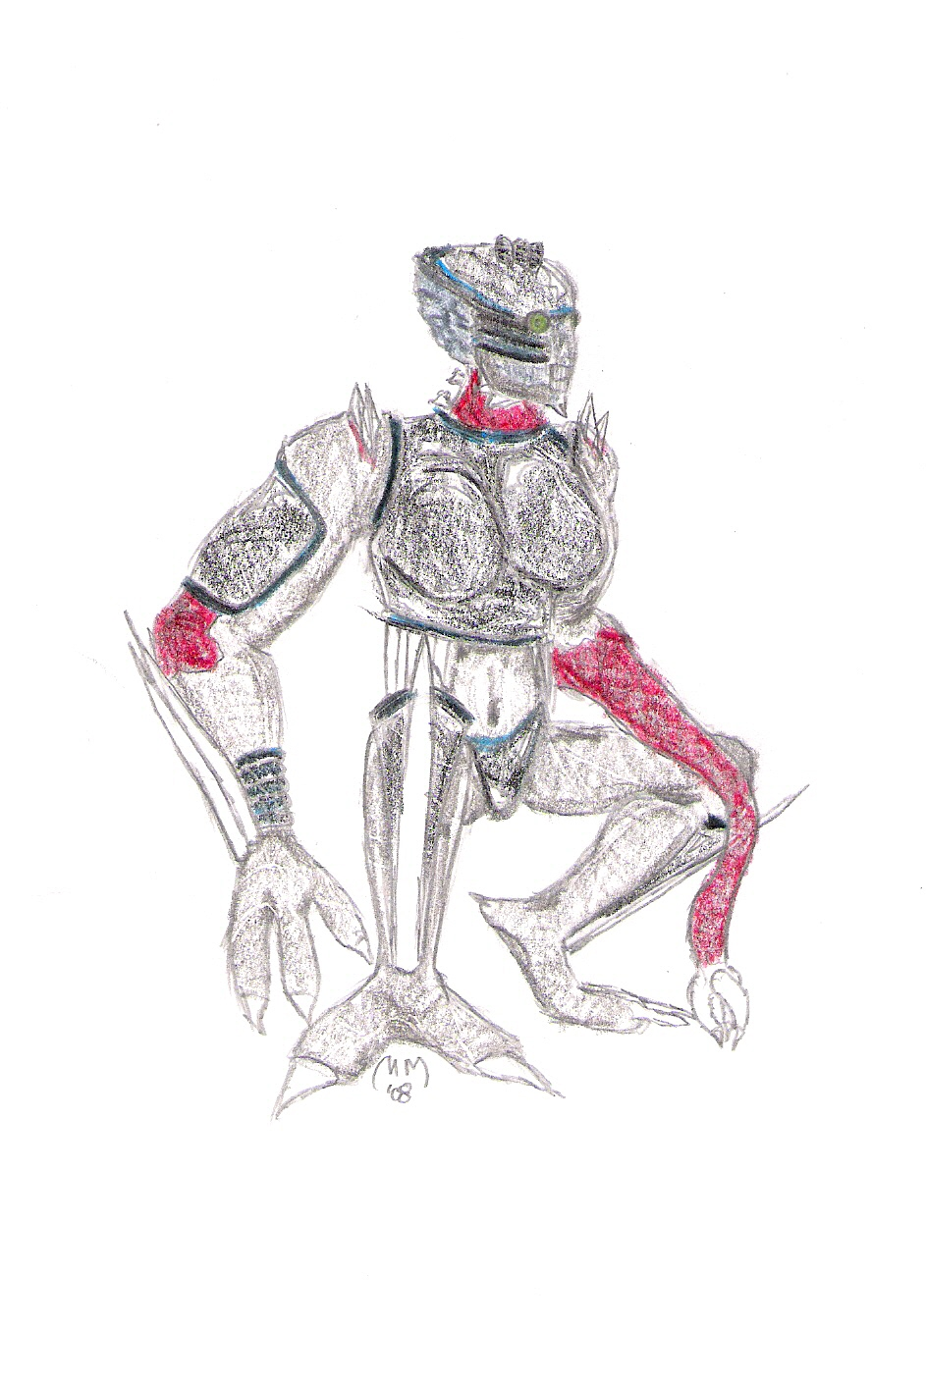
Delta_Bioform
Age: Unknown
Height: 5’ 8”
Weight: 184lbs. (of muscle, carapace, and chitin)
Eyes: Green
Hair: None
Facial Features: Gigeresque biomorphic, elongated black carapace head, biotubing, exposed brain in back, exposed jaw structure, large lidless eyes, boney protrusions
Color Scheme: black (carapace pieces, tubing), dark off-white (boney chitin, bone pieces), dark red (muscle tissue), dark grey (skin), pale blue (brain)
Characteristics: Same as Delta, more likely to become aggressive, emotional responses are dampened, bestial snarl quality to voice

Consistency Notes:
Delta, Delta_Android, and Delta_Biomorph need to be distinguishable as the same character. Using consistent color schemes will be very helpful in accomplishing this. The same applies to Justine, J.E.S.S. and jU5t33Nz, however it is less important for them to be realized as a single entity as opposed to aspects of Delta that are going haywire (soul, body, mind, respectively).
Below are two tables showing where colors should match.

 | Delta | Delta_Android | Delta_Biomorph
Light blue | Trim | Brain Sphere | Brain, Trim(tubing)
Green | Eyes | Eyes | Eyes
Black | Tubing | Body(tubing) | Tubing
Dark grey | Carbon fiber | - | Carapace
White | Plastic alloy | Body | Bone

 | Justine | J.E.S.S. | jU5t33Nz
Red | Eyes, Blood | Eyes | Eyes, Skin, Trim
Dark Green | Pants | Tubing | -
Yellow/Peach | Skin | Face | -
Black/Red | Boots | - | Hair

Proper texturing should be utilized to give different materials of the same color the proper feel. For example, Shiny White Plastic Alloy looks and feels different than Jagged Rigid Bone Fragments.

Also note ALL robots and cyborgs have similar pieces that share a similar color scheme. J.E.S.S. and Delta_Android share a similar body structure comprised of a similar material. Merlin and J.E.S.S. have the same dark green tubing (as well as the same color skin). Merlin and Delta both have one red eye, which jU5t33Nz also mimics.

