Installation of Necessary Programs

- Install Visual Studio Code
Go to https://code.visualstudio.com/ and follow the instructions for downloading Visual Studio Code on your PC.
- Install the EV3 Extension for Visual Studio Code
Open VS Code and go to File > Preferences > Extensions. Search for “EV3” and download this extension:
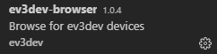
(make sure the author is “ev3dev”, there is another extension with the same name but by someone else)

Communicating with the Brick

- Power on the EV3 Brick
Press the square button in the middle to power on the device. This may take a few minutes.
- Connect the EV3 Brick to your PC using Bluetooth
Enable Bluetooth on the EV3 by navigating the menu to Wireless and Networks > Bluetooth. Turn both the Powered and Visible options on by hovering over each and pressing the square button. Then, press the square button over Start Scan.
Now, on your PC, search in the Start Menu for Bluetooth and other devices. In the window that opens, click on the Add Bluetooth or other device button at the top and select Bluetooth. Eventually, your EV3 device should appear. Click on it to connect, and accept all of the prompts that pop up on both your PC and the EV3.
Possible issues when connecting with Bluetooth:
Bluetooth is not available on the EV3 — Reboot the EV3 by pressing the Back (top left gray button) until you get a prompt to either shut down or reboot.
I can’t find my device in the list of Bluetooth devices to add — Go back and make sure all of the instructions above were followed; if Bluetooth is not properly enabled on the EV3, it will make it either very difficult or impossible to connect it to your PC.
- Connect to your EV3 in Visual Studio Code
Click on the “page” icon in the top left of VS Code to go back to the file browser. From here, you can go to File > Open Folder and open a new folder for you to put your code in. Once you open the folder, you should see this tab at the bottom left corner:
Expand this tab, and choose Click here to connect to a device. You should see a pop-up in the top-center of the window, and your EV3 device should appear there. Click on it to connect, and you should be good to go!

- Possible issues when connecting to Visual Studio Code:
My EV3 doesn’t appear in Visual Studio Code when I try to connect — Make sure that your EV3 is still connected to your PC. On the EV3, go to Wireless and Networks > All Network Connections, find your PC name, and click Connect. It should eventually say “Status: Connected” and you should be able to find it from there. You may get an Error message that says “Timeout was reached.” Just click the center button and notice that the state will either say “Configuring” or “Connected”. If it is still configuring give it time. If none of this works, you can use the cable for now.

Uploading and Running your Code

- Uploading your code:
Have the code open in the active window of VS, and Click on:
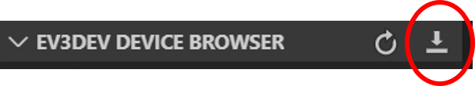
(I know, it’s confusing, but uploading your code to the robot is done through the download icon)

- Running your code

There are several options:

- Use the navigation buttons on the brick to navigate to the File Browser, and then navigate to the right folder and click on the file you want to run.

- Right-click on the file name in the menu:

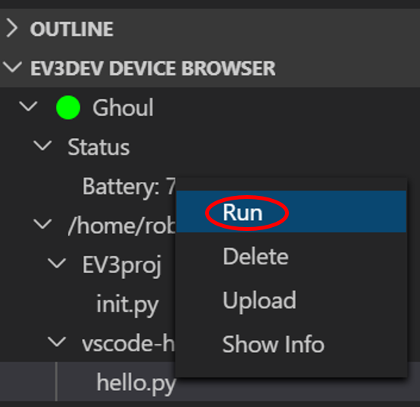
- Left-click on the file that is listed under the robot in the menus:

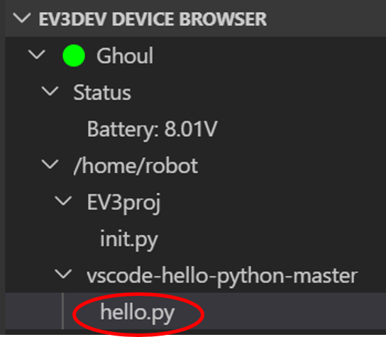

Then Click this on top of the screen:
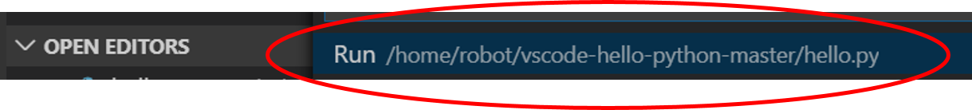

- Right click on the robot in the menus:

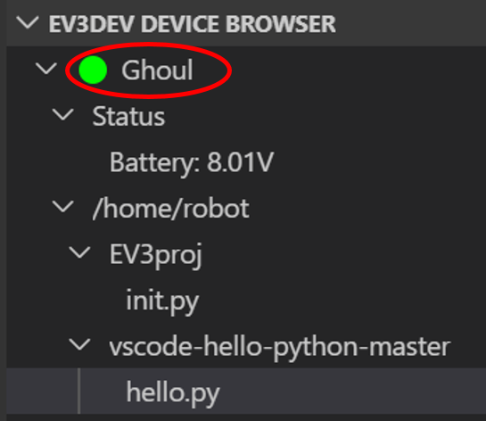
and click "open SSH terminal".

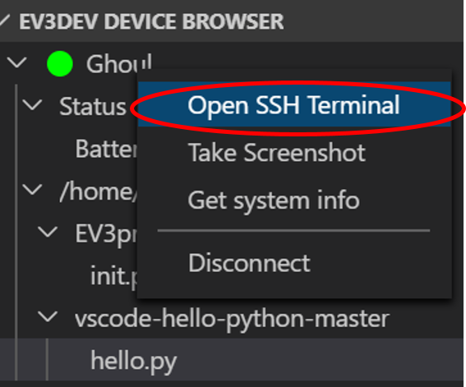

In the SSH Terminal that appears, navigate to the directory in the robot that has the file (use the command “cd” to change directory. Also, “ls” lists the files in the current directory. Run the file with the command "brickrun -r ./filename".

Use this option for providing input to the robot (such as the ‘breeze’ signals) as the program is running!

