Synergy
©Blue Screen of Death

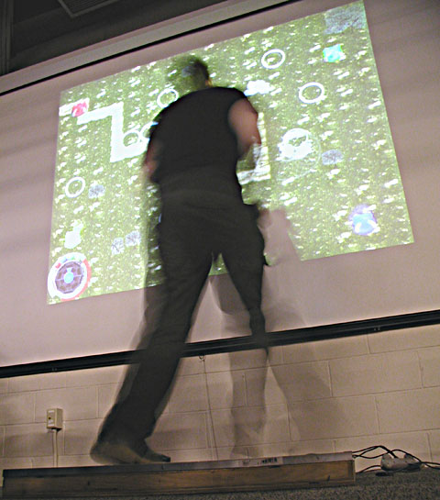

Brian Ratta- Lead Programmer
Andrew ‘Zif’ Horton- Game Designer - Maya animator
Matthew Giacomazzo - Sound Designer - 2d/character animator
I. Artist Statement/Philosophy/The WHY Factor (why create this game? why would someone want to play it?)

This game is truly an experiment in cooperative gaming, through this game we hope to demonstrate that it is possible for people to work together in a non split screen environment, and that it is possible to have a great time even when in a supporting role. People will enjoy playing this game for a variety of reasons, but it’s greatest thrill could be counting on someone else, and not knowing for sure what will happen because you are trusting someone else to a part of the task instead of doing it all yourself.

II. Predecessor or previous games/ distinctive factors in this genre

There are several games that have incorporated some of our ides for this project. Just as our game title implies multiple people working together we have combined ideas from other games and our own to create something new.
Game | Feature Description | Difference
Ikaruga | Ikaruga is a traditional bottom up scrolling space shooter game with one twist absorbing and firing black and white weapons. This feature is very similar to our implementation of the color system in red, blue, green, and yellow. Absorbing a color allows the user to release a special attack which is the same for both colors. | In our game the different colors also cause the attacks of the character to be inherently different, the play is done in solid areas instead of a scrolling interface, and attacks do not mean certain death but rather damage. We also have special attacks charged by absorbing attacks but each special for the each color will have a different effect.
DDR (Dance Dance Revolution) | This is a game in which players must quickly press arrows in sync with music. It requires excellent timing and has a unique skill set that develops of eye-foot coordination. In our project we are using the same arrow layout and skills in quickly reading arrows and performing that task with ones feet will be essential. Also the rush of physical activity is very important in this game, as it will be in ours as well. | Our game may use arrows, but they are for the most part not laid out the same way every time as in DDR. Also timing is less important than speed and accuracy. The timing in our game is not an arrow lining up but rather reactions to the gameplay and required color changes.

III. Target Audience

Our target audience is more or less the social gamer. As this is a cooperative game people who like to play alone or compete alone would probably not enjoy the game. As there is a slight consideration of people having a game pad available our main audience will most likely include people who already have a pad because of another game which uses it. However if word of mouth gets around that the game is fun on it’s own merits this would no longer be as much of an issue. In a more far thinking sense if a game of this sort were successful we could even sell our own custom pads, including graphics to go with the theme.

IV. Introduction & Story

The game is not really story driven so much as action driven. The introduction will be more an introduction to the rules of the game and how to play. Eventually we may create a “Story Mode” which fleshes out the character of our sorceress and her familiar but currently we are focusing on the game play itself.

V. Immediate and long term projected socio/cultural project impact

Games have become in many cases almost an anti-social activity. We hope our game will greatly encourage direct interaction and relationships with other people through the game’s unique interface. In the long run this kind of close interaction could stand to encourage the players to work together more fluidly and quickly. Also it may encourage the delegation and assembly of separate tasks to accomplish a greater goal, a lesson that must be learned in order to be successful in the game.

VI. Delivery System & Requirements

To package our program we are using Inno Installer. This is a free installer that is easy to use and looks very professional. Delivery can be done in two ways. One as a burned CD with our setup and install program. Second is a website where people can download our program. The requirements to run our game will include the OpenGL and glut DLLs. Our game provides these on Install.

VII. Interface

Type | Implementation
Primary movement | W,A,S,D keys control strafing of the character
Turning | The character points in the direction of the cursor, but always floats as per the primary movement (S is always straight down and so on)
Fire Primary Weapon | Left mouse click fires currently selected weapon (the current player color)
Fire Special Weapon | Ctrl-clicking causes a stored special attack to be fired, these attacks are fired in the order they were charged.
Target Weapon | Weapon will fire directly at wherever the cursor is pointing
Change active color | Hitting corner arrows in a jump (up, left; up, right; down, left; down right) will change the active color
Charge special attack | When in Charge mode, the first arrow a player hits will determine what attack will be charged (as indicated by the first block that shows up) immediately upon hitting that arrow the remaining arrows move towards the top of the screen disappearing when hit on the pad. Upon completing each segment one charge is added. This mode automatically quits when 4 charges are accrued or there is no magic power remaining.
Activate Special Attack | Right clicking activates special attack mode which drains magical power over time to be in.

VIII. User Interaction

Key/Mouse Player-> Game events
The Key/Mouse player will be constantly interacting with the various enemies and attacks on the screen. Commonly both dodging and firing, even running into same color attacks to increase magic charge.

Pad Player -> Game events
The pad player must keep changing the current active color to what is most applicable to the situation at hand, including absorbing a particular color or using a color’s attack. Also they must perform arrow combinations displayed for charging special attacks.

Player->Player
The Key/Mouse player and the Pad player will interact with each other. This could take the form of direct communication, the pad player saying “red” to turn red for example, automatic communication, the pad player changing the color on their own to one more convenient and the main player responding to this for example. And finally synergistic interaction wherein the players having gotten used to what the other will do respond to things exactly when they need to happen. The main player also activates and deactivates charge mode while the pad player chooses what color special to charge and how fast they are charged.

IX. The World Layout

The world setting is high fantasy. Expect to see plenty of trees, stone walls, and interesting decorations scattered throughout. This is a world where the brightly colored rogue crystals have taken over leaving it up to our heroine to eliminate or absorb them restoring order to the world.

X. Level Design

Currently levels are created using ASCII tile maps and are being balance to provide both challenge and a good path for the character. Monsters and crystals are placed on the map through a second object map. Eventually these maps will be tied together into larger levels but currently each one is loaded individually.

XI. Visualization- characters, flow charts,

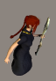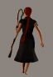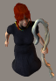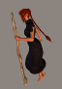

Characters
- A sorceress rendered first in poser then taken down to sprites, fitting within a 128 pixel tall area (leaving room for the familiar as well)
- A familiar, fairylike that flies around the main character leaving a streak of the currently active color, a ring rendered in Maya then influenced to give a perception of rotation.
- Enemies, one for each color and representing its element, the enemies represent rogue magic crystals so will have crystalline bodies. When attacking they will roll up and turn into whatever their attack is returning to normal if they miss.
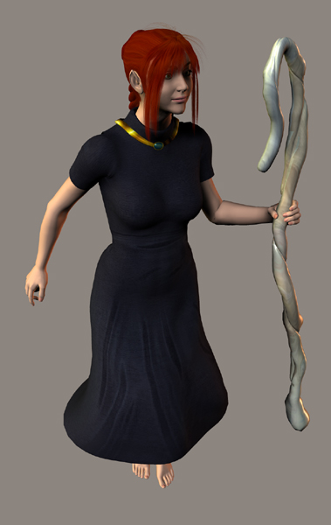

HUD
- The health bar is the half circle along the bottom of the HUD ring
- Magic level is represented in the center of the HUD by the concentric circle gauge.
- Colored spheres along the top of the HUD represent the charged special attacks.
- the right side features arrows when in charge mode that must be entered to charge up.
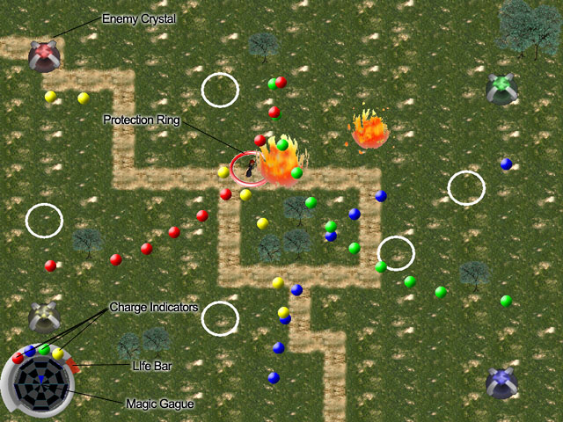

Enemies
There are two kinds of enemies presently, the first kind we call crystals, which are featured in the corners of the screenshot above. Every 8 seconds they fire out a large volume of predictable attacks in a quarter circle pattern. Hitting them with an attack causes this timer to reset.
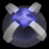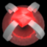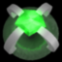
The Second kind of enemy is more dynamic; currently in the game as only white circles they will soon have an animation and an AI that will allow them to attack the player. A level will end when all of this kind of enemy has been defeated.
XII: Music/Sound Design

Sound Effect Production and Format Specs:
Sound effects will be produced and mixed from recordings and freeware sound libraries. Sound Forge 5 will serve as our main production tool and from it we shall have mastered mon 8bit 22,050hz sound samples in the standard WAV format. The reason for the slightly lower sound quality, about equal to radio, is that this is common practice to save space and put less strain on the game.

Music Production and Format Specs:
Original music will be produced through a variety of hardware and software applications eventually leading to a final mix-down in Cakewalk Pro Studio 9 and mastering in Sound Forge to a final 16bit 44.1khz WAV format file of CD quality. It will also be original and written fresh for this game.

Audio Theme/Mood Objective:
The theme of the game is high fantasy so the audio will be made to match that. Music will be big, bold, epic much like a movie soundtrack with use of multiple instrument sounds including drums, strings, horns and flute. Sound effects will be made to best match the actions be seen. When casting you’ll hear loud chanting which will be voice acted. Remember Gandalf in Lord of the Rings?

Proposed Music List:
Song Name | File Name | Length | Description
Title Music | titlemusic.wav | 1-2m ? | Opening music for the game. This piece can be a little bit more involved musically since in gameplay it needs to remain more in the background.
Gameplay Music | gamemusic.wav | 4-6m ? | Carrying the theme of the above piece this music will be in the background during gameplay bringing a mood of adventure and lurking dangers.
You Lose Music: | losemusic.wav | 30s-1m? | Again with the same theme this short music blurb will be fanfairish.
You Win Music: | winmusic.wav | 30s-1m? | Just like the above but obviously instead of a sad mood.

Proposed Sound Effect List:
Effect Name | File Name | Length | Description
Ok Click | ok.wav | v. short | Standard button click sound
Cancel Click | cancel.wav | v. short | Like above but different tone, probably lower.
Red attack | redattack.wav | short | Fireball attack sound. Sound of fireball rushing out
Red attack hit | redhit.wav | short | Sound of fireball impact
Red Special attack | redspecial.wav | Short+ | Larger explosion, followed by burning sounds of creatures taking timed damage.
Blue attack | blueattack.wav | short | Ice shooting sound
Blue attack hit | bluehit.wav | short | Freezing ice/ice break sound
Blue Special attack | bluespecial.wav | Short+ | Water vortex sound/Rushing water, creatures sucked together
Green attack | greenattack.wav | Short+ | Sound of a rolling small rock, crunching, stone on earth
Green attack hit | greenhit.wav | Short | Crash when the rock hits a crystal enemy
Green attack special | greenspecial.wav | Medium | Larger rock rolling sound.
Green attack special hit | greenspecialhit.wav | Short | Loud crack when it hits a target.
Yellow attack | yellowattack.wav | Short | Lightning crackle, chain lightning effect
Yellow attack hit | yellowattack.wav | Short | Lightning discharge
Yellow attack special | yellowspecial.wav | Short+ | Ball lightning, hits first enemy then explodes into smaller lightning balls which seek targets. (might need 2 sounds) Sizzling.

XIII. Rules and Gameplay A. Setup, B. Gameplay, C. Scoring

The Basic Rules

- A player if hit by the active color absorbs magic energy equivalent to the power of that attack
- A player hit by any other color takes normal damage
- A monster hit by its own color takes only a small amount of damage; special effects like freezing are ignored.
- A monster hit by the opposite color take extra damage to a large degree
- Special attacks are performed by activating a special attack mode; every second in this mode drains a portion of your magical energy bar.
- The pad player may charge up to 4 special attacks before they have to leave special attack charging mode.
- Special attacks must be fired in the same order they were charged, this is represented by a gauge in the lower left corner.
- Crystal attack squares will send out an arc of attacks across the screen, shooting one of these will reset its counter before it fires.

Gameplay

Gameplay will be achieved through the application of the above rules. For some examples let us refer to the player using keyboard and mouse as A, and the player on the pad as B. A will constantly be dodging attacks that are not the current color and trying to absorb attacks that are of the color. Mean while player B will be trying to make this task more possible by switching to colors that have to be passed through.

Scoring

Score Increase Events
- Enemy Destroyed
- Enemy Destroyed with opposite color (more points)
- Enemy Destroyed with same color (less points)
- Attack absorbed (small amount of points)
- Level Cleared quickly (point scale based on time to clear)
- Total enemies destroyed (point scale based on amount cleared in level)
- Multiple Enemies Destroyed (bonus points for killing more than one enemy in an attack, also keeps track of how many the most was for end bonus)
- Lives remaining (bonus points for not using all lives to get to the end)
Score Decrease Events
- Used a continue, remove all points

XIV. Program Structure

We have created a hierarchical structure starting from a top level class for our game. The main class at the top handles most of the gameplay including detecting collision and keeping track of the other objects. A level down there is an object class that all other objects will inherit from. Everything in the program will follow this same set of rules to make adding new objects a simple task requiring little re-coding. Other specific classes have been added to handle unique elements of gameplay such as the special attack charging interface.

XV. Technical Specs: Physics, Rendering System, Lighting Models

Rendering- All rendering will be done using OpenGL and Glut. We will be pre-rendering sprites into bitmaps for the game to display. These will be created through a combined use of Photoshop, Maya, Poser, and Bryce.

Physics-We are using a simple 2D movement engine which takes into account velocity and acceleration. This will be demonstrated through monsters and the character colliding and bouncing off walls and each other, knock back attacks, and the sliding movement of the main character.

Lighting- We aim for consistency in how the scene is lit by placing our light sources in the same place in the various rendering applications we are using, we have decided to place the light about 45 degrees up and to the left.

XVI. Implementation

While this concept could work in either a 2d or 3d interface in the interests of time we have decided to go with a 2d interface. We feel that this will not detract from the gameplay as it will not harm the cooperative aspect of the game. By designing the game to have more controls than one person can handle easily we hope to encourage a new level of cooperative gameplay. The pad system is also another way we are differentiating the two tasks to tie together this synergistic effect.
XVII. Production Timeframe

Task  Underline=Completed | Person | 10-12 | 10-19 | 10-26 | 11-2 | 11-9 | 11-16 | 11-23 | 11-30 | 12-4
Design
Initial Design Document | Zif
Revised Design Document | Zif
Game Web Design | Zif
Game Web Content | Zif
Art
Scrap test images | Matt
Finished main Character | Matt
Main character animation | Matt
Full set of MC cells | Matt
Familiar full cell set | Zif
Fire ball animation | Matt
IceShard/freeze animation | Matt
Boulder Roll animation | Matt
Chain Lightning animation | Matt
Fire Storm Special | Matt
Blizard Special | Matt
Earthquake Special | Matt
Ball Lightning Special | Matt
red enemy | Zif
blue enemy | Zif
green enemy | Zif
yellow enemy | Zif
3d Walls | Matt
Grass Tiles | Matt
Road Tiles | Matt
Tree Tiles | Matt
Wall Tiles | Matt
Area assembly files | Zif
Level assembly files | Zif
Startup Screen | Zif
Corner Hud
Sound FX
Ok Click | Matt
Cancel Click | Matt
Red attack | Matt
Red attack hit | Matt
Red Special attack | Matt
Blue attack | Matt
Blue attack hit | Matt
Blue Special attack | Matt
Green attack | Matt
Green attack hit | Matt
Green attack special | Matt
Yellow attack | Matt
Yellow attack hit | Matt
Yellow attack special | Matt
Music
Title Music | Matt
Gameplay Music | Matt
You Lose Music | Matt
You Win Music | Matt
Programming
Basic Movement | Brian
Cursor Tracking | Brian
Color Changing | Brian
Frame limiter | Brian
Tile from file loader | Brian
Level Loader | Brian
Room Switching | Brian
Fireball | Brian
Ice attack | Brian
boulder attack | Brian
lightning attack | Brian
firestorm | Brian
Water Vortex | Brian
earthquake | Brian
Ball lightning | Brian
Music loader | Brian
Enemy loading | Brian
red AI | Brian
Blue AI | Brian
Green AI | Brian
Yellow AI | Brian
HUD loading/updating | Brian
Basic Collision | Brian
Tuned Collision | Brian
Special attack charging | Brian
right arrow panel showing | Brian
MC integration | Brian
Familiar integration | Brian
Sound FX loader | Brian
Final game assembly/Testing | Brian

XVIII. Research

We looked into various game that have had cooperative gameplay and found that nearly all of them required that both players do the same function just through some kind of split screen function. Other examples of cooperative gameplay involve crafting on MMORPGs, or games where you control two separate vehicles or characters who sometimes work together. The closest style of gameplay I found was in a game called wakeboarding unleashed where one character could control a boat while the other skied behind it. Still our conclusion was that in general games do not require that players work directly together to influence just one character on the screen.

XIX. References

Open GL game programming, Kevin Hawkins, Dave Astle, Primatec
Open GL Programming Guide (red book)
A list of playstation 2 games with cooperative elements http://charon.sfsu.edu/corey/ps2coop/
A review of the best CO-op games on the market for ps2. http://ps2.ign.com/articles/427/427229p6.html

