
Flippin’ Awesome ©2008
Created in Experimental Game Design, Spring 2008
at Rensselaer Polytechnic Institute

Developers
Ian Keyworth (keywoi@rpi.edu) – Game Design, Lead Programmer
Ray Coulter (coultr@rpi.edu) – Game Design, Level Design, Sound Design
Rory Pelner (pelner@rpi.edu) – Lead Level Artist
Chris Mui (muic@rpi.edu) – Character Design and Animation

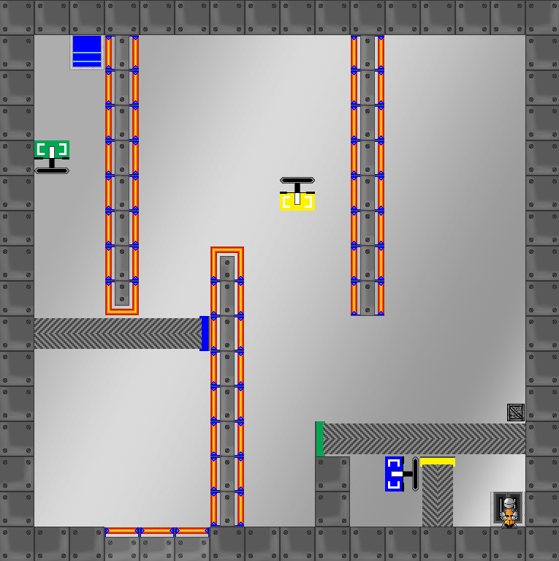
Programmed and run in Java, Nova Radix follows in the line of recent puzzle games, like Valve's Portal, and Shift, of Armorgames, and expands on a new environmental mechanic. The player controls a robotic character exploring an abandoned spacecraft. The twist (no pun intended) is that you have the ability to pivot the 2-D room 90 degrees at any time, effectively changing the direction of gravity. You can use this power to fling yourself over obstacles, reach unreachable switches and gates, and make your way to the exit, tunneling through this strange and dangerous environment. All graphics were made using Adobe Photoshop, and Eclipse was used to write and compile the code.

