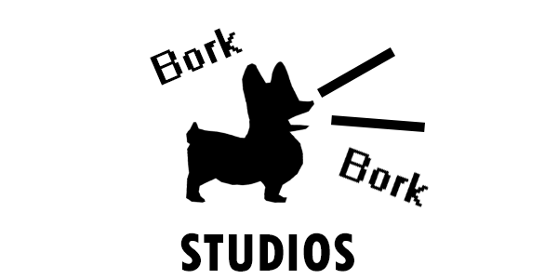

Design Document for:

Good Doggo

Amanda Howanice, 3D rigger/animator howana@rpi.edu
Camron McCormack, Programmer lionheart365@gmail.com
Stephen Wood, Programmer woods5@rpi.edu
Vahan Ionnisian, 3D/2D Artist, Sound Designer ionniv@rpi.edu
Brittany Wendzel, 3D/2D Artist - wendzb@rpi.edu
Enoch Huang, Programmer - huange2@rpi.edu

All work Copyright ©2017 by Amanda Howanice, Camron McCormack, Stephen Wood, Vahan Ionnisian, Brittany Wendzel, Enoch Huang

Table of Contents
Introduction & Story
NAME OF GAME 1
SUMMARY 4
PHILOSOPHY 5
GAME OVERVIEW 5
DESIGN HISTORY 6
Version 1.0 6
Version 1.1 6
Version 1.2 6
Version 1.3 6
Version 1.4 6
FEATURE SET 7
General Features 7
Editor 7
Game play 7
THE GAME WORLD 8
Overview 8
The Physical World 8
Overview 8
Key Locations 8
Travel 8
Scale 8
Objects 8
Day and Night 8
Time 9
Camera 9
Overview 9
Game Engine 9
Overview 9
Lighting Models 9
Overview 9
THE WORLD LAYOUT 10
Overview 10
GAME CHARACTERS 11
Overview 11
Customizing Doggo 11
Challenges 11
QUESTS 12
Overview 12
Quest 1: Dive Bombing Birds 12
Quest 2: Bubbles 12
Quest 3: Lure Racing 12
Quest 4: Angry Neighborhood Dog 12
Quest 5: Puzzle Backyard 13
USER INTERFACE 14
Overview 14
User Interface Detail #1 14
User Interface Detail #2 14
MUSICAL SCORES AND SOUND EFFECTS 15
Overview 15
SINGLE PLAYER GAME 16
Overview 16
Story 16
Hours of Game-play 16
Victory Conditions 16
Playtesting Results 17
Session 1: November 27th 17
Session 2: December 2nd 17
Research 18
OBJECTS APPENDIX 19

Good Doggo
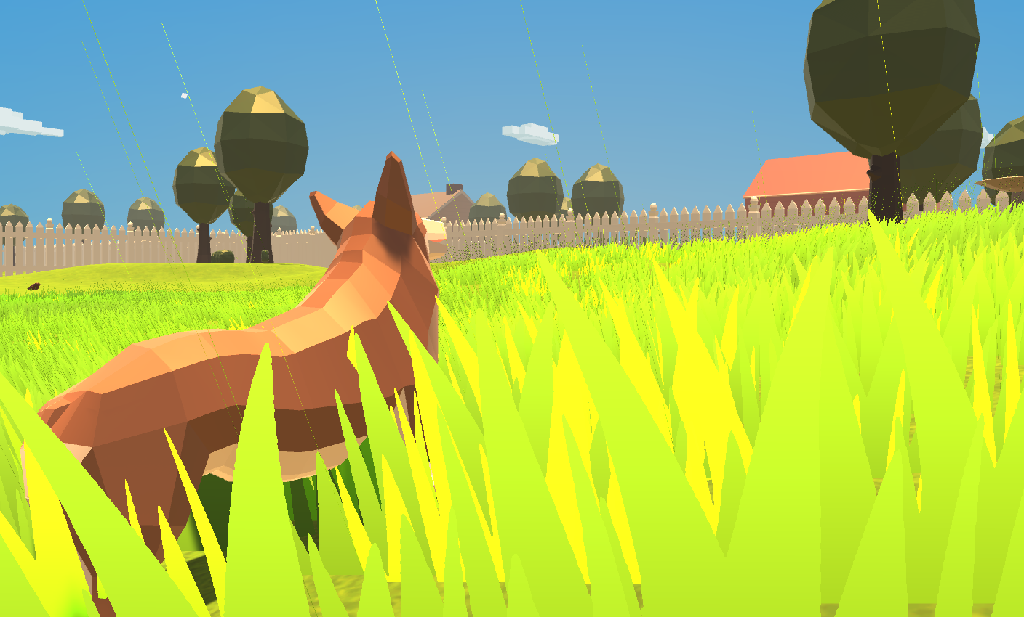

Good Doggo is a 3D third-person perspective game where players take on the role of a corgi puppy in a series of neighborhood backyards. Players can play with toys, eat food, bark at birds, travel to other backyards, and interact with neighborhood dogs on their quest to explore the great unknown. This is a PC game made in Unity 2017.1.

All work Copyright ©2017 by Amanda Howanice, Camron McCormack, Stephen Wood, Vahan Ionnisian, Brittany Wendzel, Enoch Huang

Game Philosophy

Why create this game?
- We are creating this game to serve as a fun, casual experience in translating the experiences of a dog to the average person. This game is intended to have emergent fun as a result of its open world and wide range of possible interactions with objects in the world.

Immediate and Long Term Projected SocioCultural Project Impact?
- We hope that our game will have a positive influence on those who play it, and that they will feel a sense of calm and relaxation while they play. We also hope that this game will give them a greater appreciation for their pets of all shapes and sizes and that playing this game will encourage player to seek out enriching toys to give their pets when they’re away from home. We hope this game will encourage future games to keep pushing the boundaries of emergent gameplay and find new and creative ways to frame our everyday lives as adventures waiting to happen.

Predecessor or previous games/ distinctive factors in this genre?
- Similar games include Nintendogs and Goat Simulator. Our gameplay is different from most similar games since you play as the dog, rather than take care of a dog. We will also provide more substantial gameplay than games like Goat Simulator where one of the main draws is the bugs.

Target Audience?
- This game is intended for pet-loving teenagers and young adults of all genders and races, but may also be enjoyable for older adults as well.

Game Overview

Common Questions

What is the game?
- A 3D open world game in which the player takes on the identity of a corgi puppy and interacts with the world around them. The game is in third-person (or dog) perspective, and puts the player in total control of where they go and what they do. There are no direct goals or objectives given, but there are some “quest” elements added in via other neighborhood dogs that the player can interact with for unlockable flight mode.

Where does the game take place?
- The world is an average, white picket fence, suburban neighborhood, taking place mostly within the backyards near the player’s own backyard. Common backyard objects such as trees, birdbaths, doghouses and other objects can be found in the different backyards.

What do the players do?
- Players have a wide range of interactions with the different objects in their world. Some of these include: picking up toys, barking, running, chasing their tail, digging, eating food, barking at other dogs in the neighborhood, bringing toys to other dogs in the neighborhood, chasing birds, chasing squirrels, and flying (an unlockable mode in which the dog can fly over fences).

How many characters are involved?
- There are five dogs other than the player character in the neighborhood (see “Game Characters”) along with birds and squirrels.

What is the main focus?
- We want to create a sense of fun, play, and relaxation for the player through living the life of a puppy. Achievements are created by the things the player accomplishes, and goals that they set for themselves - maybe trying to get the ball over to the Pomeranian across the street, or feeling satisfaction in chasing all the squirrels out of the yard. Since our game is largely based around emergent fun, the experience itself is what we want our players to experience.

Design History

Version 1.0

Version 1.0 is the first version of this document as brought to class on 10/18/2017. It includes most of our ideas based off the game we started with and or design decisions going forward.

- Filled out most of the template design doc.

Version 1.1
Version 1.1 is a cleaned up and fleshed out version of 1.0. We filled in all missing areas of the document and added additional information as needed.

Version 1.2
Version cleaned up some simple formatting and added in information about research that we have done.

Version 1.3
Game image swapped out for current screenshot and summary tweaked. Game Character section updated with dog names.

Version 1.4
Locations updated with yard names, various tweaks to the wording of certain sections. Added a section about playtesting results. Fixed various issues and updated table of contents.

Feature Set

General Features

Expansive backyard world
Interactive dog toys
Other NPC dogs the player can interact with
Other squirrels/birds the player can interact with
3D graphics

Editor

Unity 2017.1, using C#

Gameplay

Run around the yard
Bark at other dogs
Bark at birds and squirrels
Interact with other dogs to unlock toys
Dig holes to escape into neighboring yards
Play with dog toys
Eat food

The Game World

Overview

The game takes place through a series of backyards. The player starts off in a backyard with some squirrels and birds. The player can dig under the fences that keep them in the yard to explore the neighboring yards. Many of these other yards that the player can explore have other dogs in them. These dogs give the player a variety of tasks to complete, many of which will require the player to travel to other places in the neighborhood to complete.

The Physical World

Overview

- A neighborhood in a suburban setting, especially focused on the backyards.

Key Locations

- Doggo’s Yard (“Home”)
- Tiffany’s Yard
- Bubbles’s Yard
- Rex’s Yard
- Seabiscuit’s Yard
- Blackie’s Yard

Travel

- Travel is done mostly through normal player movement. However, in some cases tasks need to be performed in order to progress to new areas. This allows blocking or allowing travel in a few ways: NPCs blocking a path, holes that can be dug into other yards, or on some cases flight.

Scale

- Six backyards total.

Objects

- A number of dog toys can be found to play with. Some have practical uses such as finding a specific toy for an NPC, others are simply aesthetic.

See the “Objects Appendix” for a list of all the objects found in the world.

Day and Night

- Day night cycles will be present in the game, with a full cycle taking around 40 minutes (25 day and 15 night). There will be a dog house available for players to use to change the time.

Time

- The game will play in real time, with shorter than realistic day/night cycles as described above.

Camera

Overview

The camera will be a third-person camera behind the dog. The player can pivot it around the dog by moving the mouse. The dog’s movement is determined by the direction the camera is facing.

Game Engine

Overview

The game is made using Unity 2017.1. It uses the default Unity collision detection and physics.

Lighting Models

Overview

Basic daylight and nighttime light schema.

The World Layout

Overview

As of Version 1.1, there are a series of backyard set up in a grid, separated by white picket fences. Since version 1.4, there are dogs that the player can interact with in the yards immediately adjacent to the player’s yard, as well as a few tasks that these dogs give. There are no humans that can be found in the world. Our explanation for this, which will be at most hinted at to the player and not directly told to them, is that the families in the neighborhood are on summer vacation, and the dogs are left outside to play with someone coming by (that the player doesn’t see) to give them food, water, etc.

Game Characters

Overview

Doggo, the Corgi puppy - The main player character
Neighborhood dogs:
Tiffany, the Pomeranian puppy - A neighborhood dog with a sparkly collar
Bubbles, the Jack Russell Terrier puppy - A neighborhood dog obsessed with bubbles
Rex, the Corgi puppy - A neighborhood dog who barks because he’s bored and chases anything that comes into his yard
Blackie, the Pomeranian puppy - A neighborhood dog who loves puzzles
Seabiscuit, the Jack Russell Terrier puppy - A neighborhood dog who prides himself of his speed
Squirrels - AI-driven squirrels that run from dogs when chased or barked at
Birds - AI-driven birds that flee from dogs when chased or barked at

Challenges

See “Quests”

Quests

Overview

As the player goes from yard to yard, they encounter a variety of other dogs in the world. Some of these dogs have a quest or a series of quests to complete. When the player finishes the last quest for any given dog, that dog will give the player a piece of food. The victory condition for the game is to collect all the pieces of food from all the different dogs, which will unlock a bonus ability (flying). As of version 1.4, quest 1 is completed and parts of quest 2 are available, and the remaining quests are still in the process of being implemented.

Quest 1: Dive Bombing Birds

In this quest, the player comes across Tiffany, a Pomeranian, who is hiding inside a dog house because of a flock of birds that are constantly pestering them. The player must bark at the birds to drive them off. After doing this, the player is shown that Tiffany has a shiny dog collar on it, which is attracting the birds. Tiffany indicates that she needs a bandana to cover up her collar. The bandana is located in Bubbles’s Yard, and is the reward for beating Bubbles’s high score. After acquiring the bandana and bringing it back, the quest will be complete and the player will be rewarded with a bowl of food.

Quest 2: Bubbles

This quest focuses on Bubbles, a Jack Russell Terrier, who has a bubble machine to keep them amused. When the player first arrives in the yard, the bubble machine will be missing the soap needed to actually create the bubbles. The player must bring to the machine soap to activate it. The soap will be located in the yard that the player started on, perched on an open windowsill. To get it down, the player must hit it with a tennis ball, which will then allow them to pick it up. When the player brings the soap back to the bubble machine, it will turn on. The player can then interact with the dog in this yard to start a minigame where they need to pop a certain number of bubbles within a time limit. If they complete the task, they are rewarded with another toy filled with food.

Quest 3: Lure Racing

This quest focuses mainly on a lure racing course set up in a large yard. When the player first interacts with the dog that lives in this yard, the dog challenges the player to catch the lure as it moves around the track. Once the player does this, the dog will give the player the bandana, which is needed to complete quest 1. The dog will also ask for a toy, because this dog’s owner has not given him any. The player will need to bring the dog one of the toys in the player’s yard. After doing this, the player can challenge the other dog to a race on the lure course. If the player beats the other dog in the race, they will be given another toy filled with food.

Quest 4: Angry Neighborhood Dog

This quest focuses on a noisy neighborhood dog that dislikes the player. This dog is exceedingly bored, and wants toys with different smells. Throughout the world, there will be various objects that have strong scents. If the player brings a toy close to one of these for long enough, the toy will gain that scent. They player needs to then bring this dog a toy with each of the different scents throughout the world at nighttime (when the other dog had become tired out of hating you). Once the player has brought all the different smelling toys, they will get another toy filled with food.

Quest 5: Puzzle backyard

This quest focuses on a dog that lives in a yard with a lot of kids who spend time playing sports outside. They player will need to complete a series of puzzles using things found in the yard. After completing the puzzles, the player will get another toy filled with food.

User Interface

Overview

As of Version 1.4, we have a simple image that can be toggled on and off in game to show the basic controls of the game. We also have a UI element that shows the name of the yard that the player enters briefly once they enter into that yard. There is also a simple UI for the bubble minigame that shows the time remaining and the current player’s score. There are also a few different icons that appear above the player’s head when there is something that they can dig through.

Musical Scores and Sound Effects

Overview

Light and ambient, with most sound coming from the player..

3D Sound

Unity’s sound engine is fairly robust, but 3D sound is not a priority, since the player doesn’t need to know with rapid immediacy, where a sound is coming from, as they might in a shooter.

Sound Design

Sound design consists mostly of the sounds that the player, a small puppy, would be able to make, in addition to outdoor summer ambience.

Music

The Good Doggo theme (composed by Amanda Howanice) plays throughout the game, with the exception of flight mode, which plays the song “Flight” by Waterflame.

Single-Player Game

Overview

The player plays as a corgi puppy in their otherwise deserted backyard. Play consists of the player exploring and interacting with objects, figuring out how all the systems work and work together, and discover new capabilities and combinations of actions. After exploring their own yard, the player is able to dig under the fences around their yard to explore the other yards in the neighborhood, and interact with the other animals that live in them.

Story

Story is mostly player-based, with the player creating their own story through emergent gameplay. The dogs in other yards give the player simple tasks to complete as well.

Hours of Gameplay

- This will vary widely from player to player. Completionists will likely finish the game within 15-20 minutes, but players who are more interested in the emergent gameplay will probably play upwards of 30 minutes.

Victory Conditions
- None. The game in intentionally designed to have no victory. We want players to have more freedom in what they do, rather than to follow a line to the end. Doing everything there is to do and completing the quests could be considered a victory condition by some, but is not displayed as a victory in game. Additionally, one could argue that “flying mode” is an end game condition, but using it and/or unlocking it does not cause the game to end.

Playtesting Results

Session 1: November 27th
In our first playtest session, we had an early build of Good Doggo available for people to play. This session helped us work out a lot of bugs for player movement and movement between yards. We also were also able to determine that the quests that we gave the player were too vague, and needed to have more direction on how to proceed. Players also disliked the lack of different things that they could do in other yards, saying that the world felt empty. We also got a lot of feedback on how players enjoyed the flight mechanics that were turned on for the end of the game.

Session 2: December 2nd
Our second playtest session took place at RGS. We had fixed the majority of movement issues by this point, and we saw reactions about the movement go from mostly negative to a lot more positive, where players tended to enjoy just running around and playing as a dog. There were still some complaints about the subtleties of movements, but the issues that were making the game very hard to play were fixed. There were still some complaints about the interaction between the player and the other dogs, but because of changes we made in the interactions the quantity of these complaints lessened.

Research

Overview

Sources
Sutton, E. (2017). Art, Animals, and Experience: Relationships to Canines and the Natural World. New York, NY: Routledge.
- Information about how dogs have been portrayed in other works of art.
“Mental Enrichment With Toys and Games | Teacher's Pet With Victoria Stilwell.” YouTube, EHowPets, 28 Sept. 2012, www.youtube.com/watch?v=q1bTPuhVHY0.
- Inspiration from various potential toys and puzzles
  - Bone puzzle being considered
“7 Things Your Dog Wants On Amazon.” YouTube, The Future Is Now, 5 Jan. 2017, www.youtube.com/watch?v=aNkMJRfMxmY.
- Inspiration for various potential toys and puzzles
  - Windmill toy being considered
Best Practices: Kennel Enrichment. (2016). [PDF] Animal Farm Foundation, Inc. Available at: http://www.animalfarmfoundation.org/files/Kennel_Enrichment_MAR2016.pdf [Accessed 24 Oct. 2017].
- Stresses the importance of sound and scent for dog enrichment
  - Scent mechanic added to the game as a result
- Inspiration for various potential toys and puzzles
  - Scent-based quests
  - KONG toys
  - PVC pipe toys being considered

“Objects Appendix”
- Tennis Ball
- Kong toy
- Ring toy
- Player food bowl
- Birdbath
- Tree
- Bush
- Fence
- Fence gate
- Houses
- Tennis ball shooter
- Bone
- House
- Bird
- Squirrel
- Raccoon
- Soap
- Bandana
- Bubble machine
- Shiny collar
- Dog house
- Lure
- Lure course

